Hi, and thanks for purchasing my LCD replacement kit for the Pure Evoke Flow series of radios.
Please note that the display is not supported or endorsed by Pure Ltd. D&H Pye Ltd cannot be liable for any damage that occurs to the radio from incorrect use or installation of the kit.

Introduction

The reason the kit is needed is because the original OLED display the radio used is no longer available. This kit uses an LCD screen with attractive blue backlight. This should hopefully be longer-lasting than the original OLED screens supplied with the radio. The circuit board that is supplied contains a preprogrammed microcontroller, which translates the protocols between the radio and the LCD screen, and also handles the dimming of the backlight.

Fitting instructions
It is worth reading through the set of instructions first so you know the outline of the procedure before you start.
Place the radio on its front, either on a cloth/towel or a surface that won’t scratch it.
Remove the six black screws shown in the picture below (circled in purple).
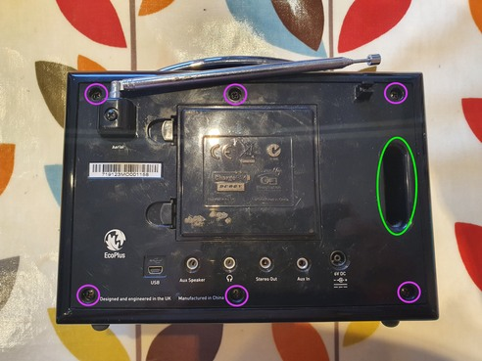

Once you’ve done this, separate the back of the radio carefully and lift it slightly to the right as you do to clear the edge of the case. It’s often useful to insert your fingers in the ‘bass channel’ circled in green on the above image to help. You’ll find the two halves of the radio are connected by a number of wires and cables, so don’t separate them too far.

With care you should be able to position the two halves of the radio as shown below: If the cables are a bit short, you can rest the ‘upright’ section of the radio on a suitable object to avoid the cables being too stretched. On the image below, you can also see (circled in purple) the four screws that hold the display holder panel in place, as well as the ribbon connector that joins it to the board (circled in green).
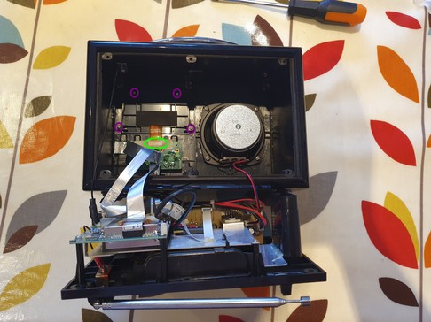

Some models have masking tape and/or hot glue over the connector -if so, gently peel it back enough to be able to see where the orange cable enters the connector, as well as the two black retaining lugs (arrowed in pink below)

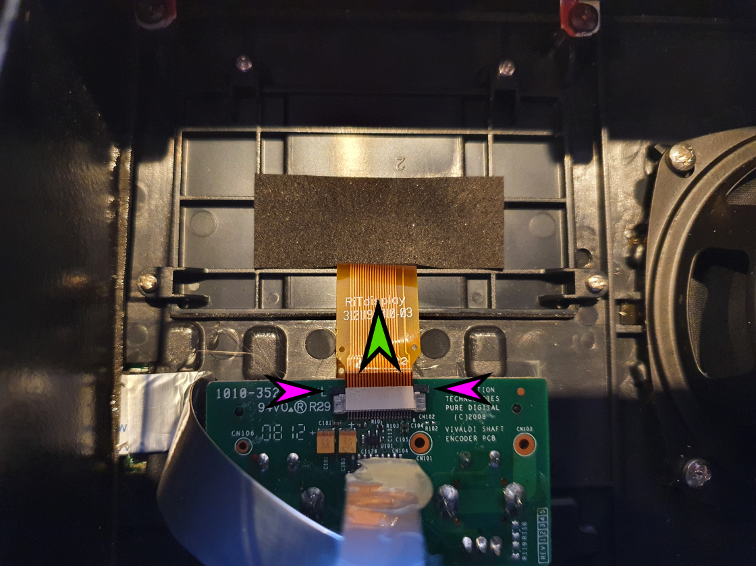
You only need to be able to peel back enough to be able to access the black retaining clips on the top of the connector where the orange cable enters it (highlighted by the pink arrows) – use a fingernail (or a small screwdriver type tool) to move each clip in the direction shown by the green arrow. They move probably around 1-2mm or so. Once they’re both released, the orange-coloured cable should slide easily out of the connector.

Next undo the four display panel retaining screws (circled in purple on the image below), and lift the panel and display out of the radio.

Also, there is a silver coloured ribbon cable directly below the orange one you have disconnected – this also needs to be unplugged from the circuit board shown below, as we will need to connect it to our new board. It is circled in blue (below). Sometimes it has been stuck down/folded with some hot glue – this should come off with gentle finger pressure. The cable just pulls up and out from the connector – there are no retaining lugs holding it in.

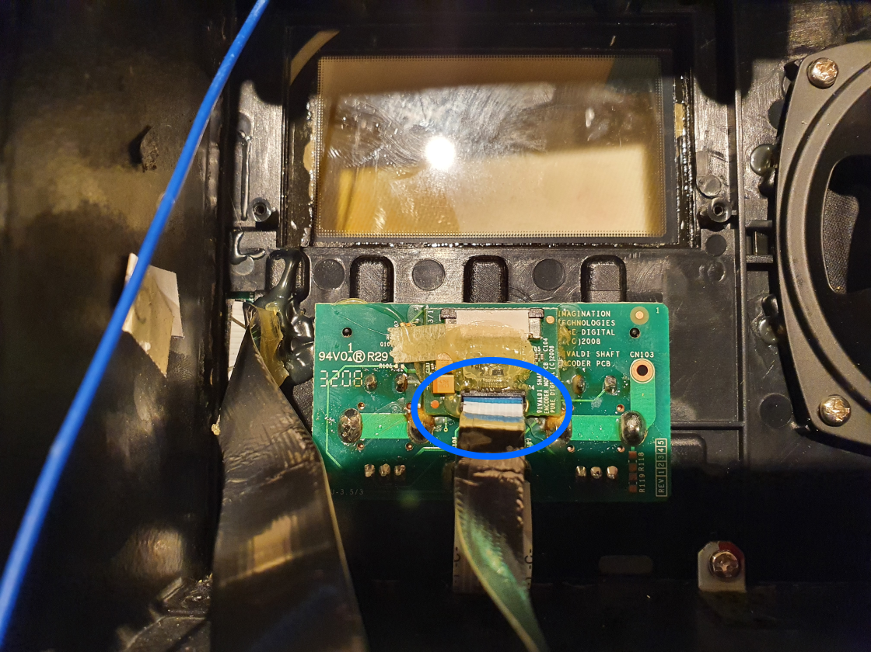

Preparing to install the new display

The old display and bracket can be discarded, but it would be advisable to keep the OLED mounting bracket, in case you decide to reinstall an OLED display one day.

If need be, you might want to clean the clear plastic window the display sits behind, to make sure there is no dust or fluff. A cotton bud or similar dipped in meths (and another to dry it) is ideal for this.
Inspect your kit:
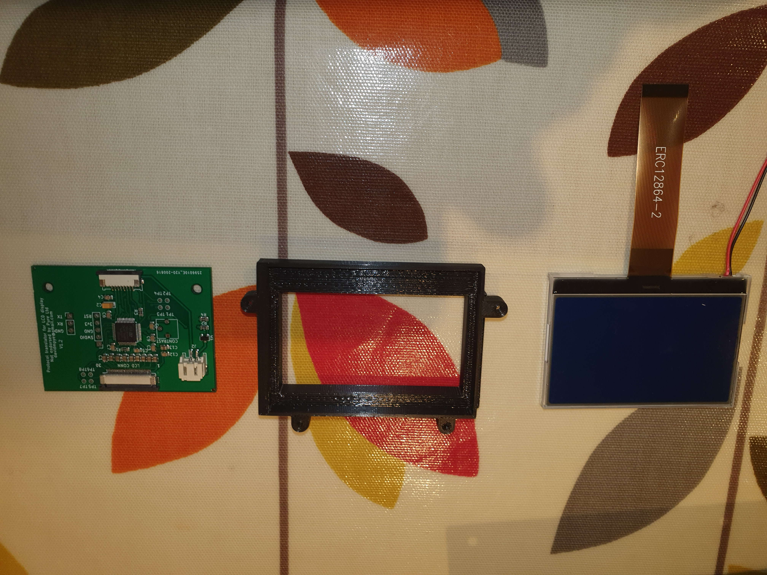

Your new kit consists of the following 3 parts
Plastic mounting frame
LCD screen
Interface circuit board

Use your fingernail at the corner of the LCD screen to lift the thin plastic screen protection layer from the front of the LCD, and peel it off (don’t get fingerprints on the screen).

Now, gently insert the screen into the mounting bracket as shown below (make sure it’s the same way up as the picture below), and press gently and firmly to ensure it is fully pressed into place. Once in place, it should be approximately flush with the back of the bracket.

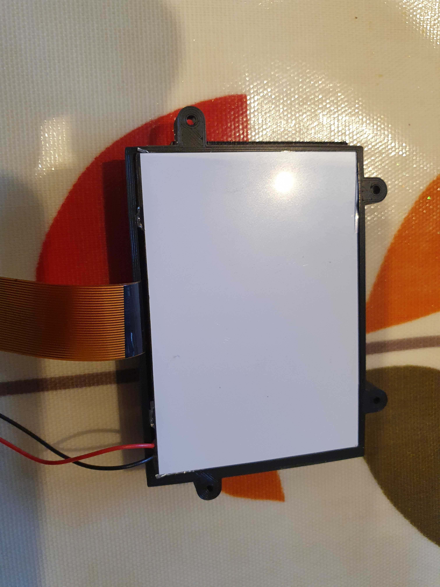

Next, it is time to connect the display to the green circuit board.

Follow the instructions below to connect the orange coloured ribbon cable to the longer of the two white sockets:

Ensure that the black retaining clip is gently pulled towards the edge of the board (away from the white body of the connector) using a fingernail. Don’t pull it too hard or too far or it may break.

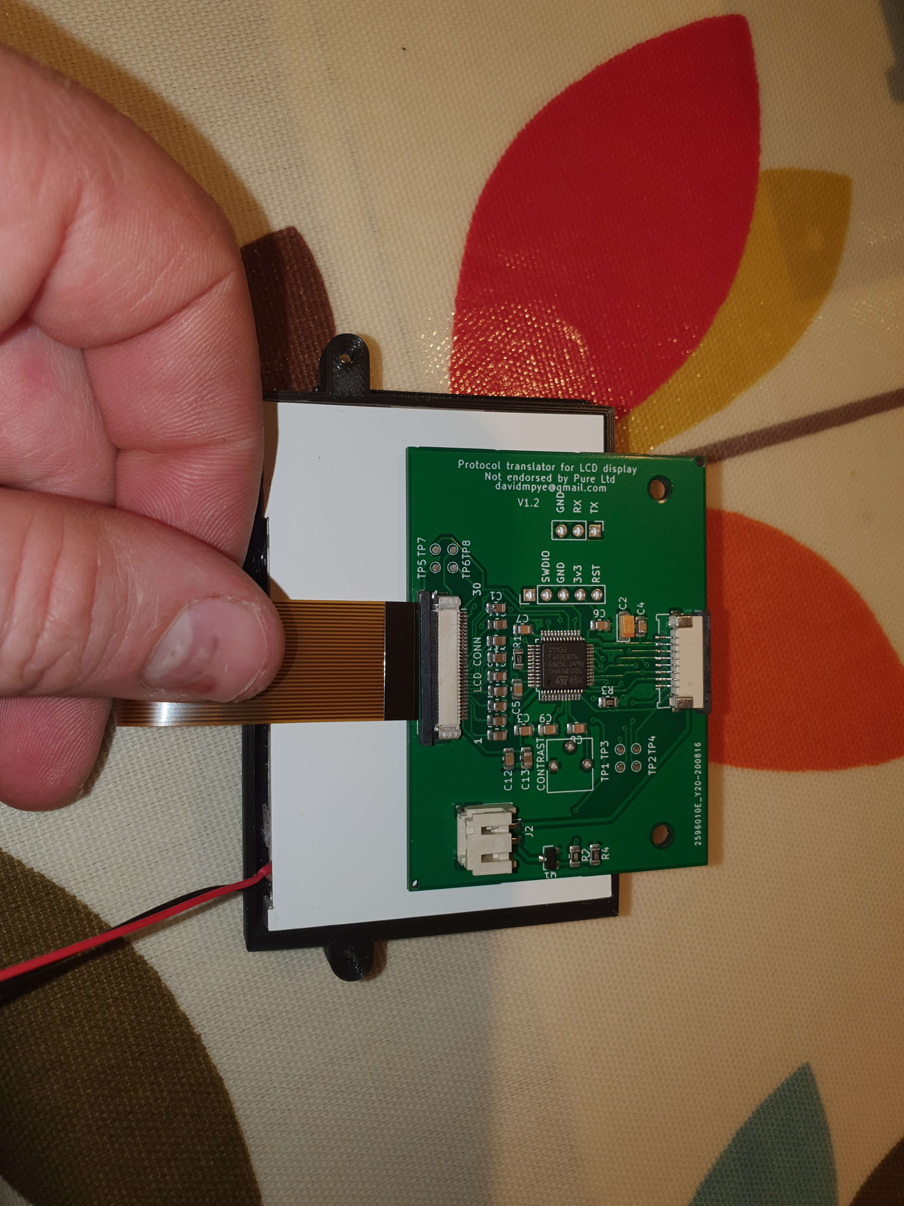
Then, guide the cable in to the socket (copper contacts facing DOWN towards the board) as follows:

Once the cable is fully inserted, push the retaining bar back in so it is flush with the connector body, gripping the cable firmly in place.

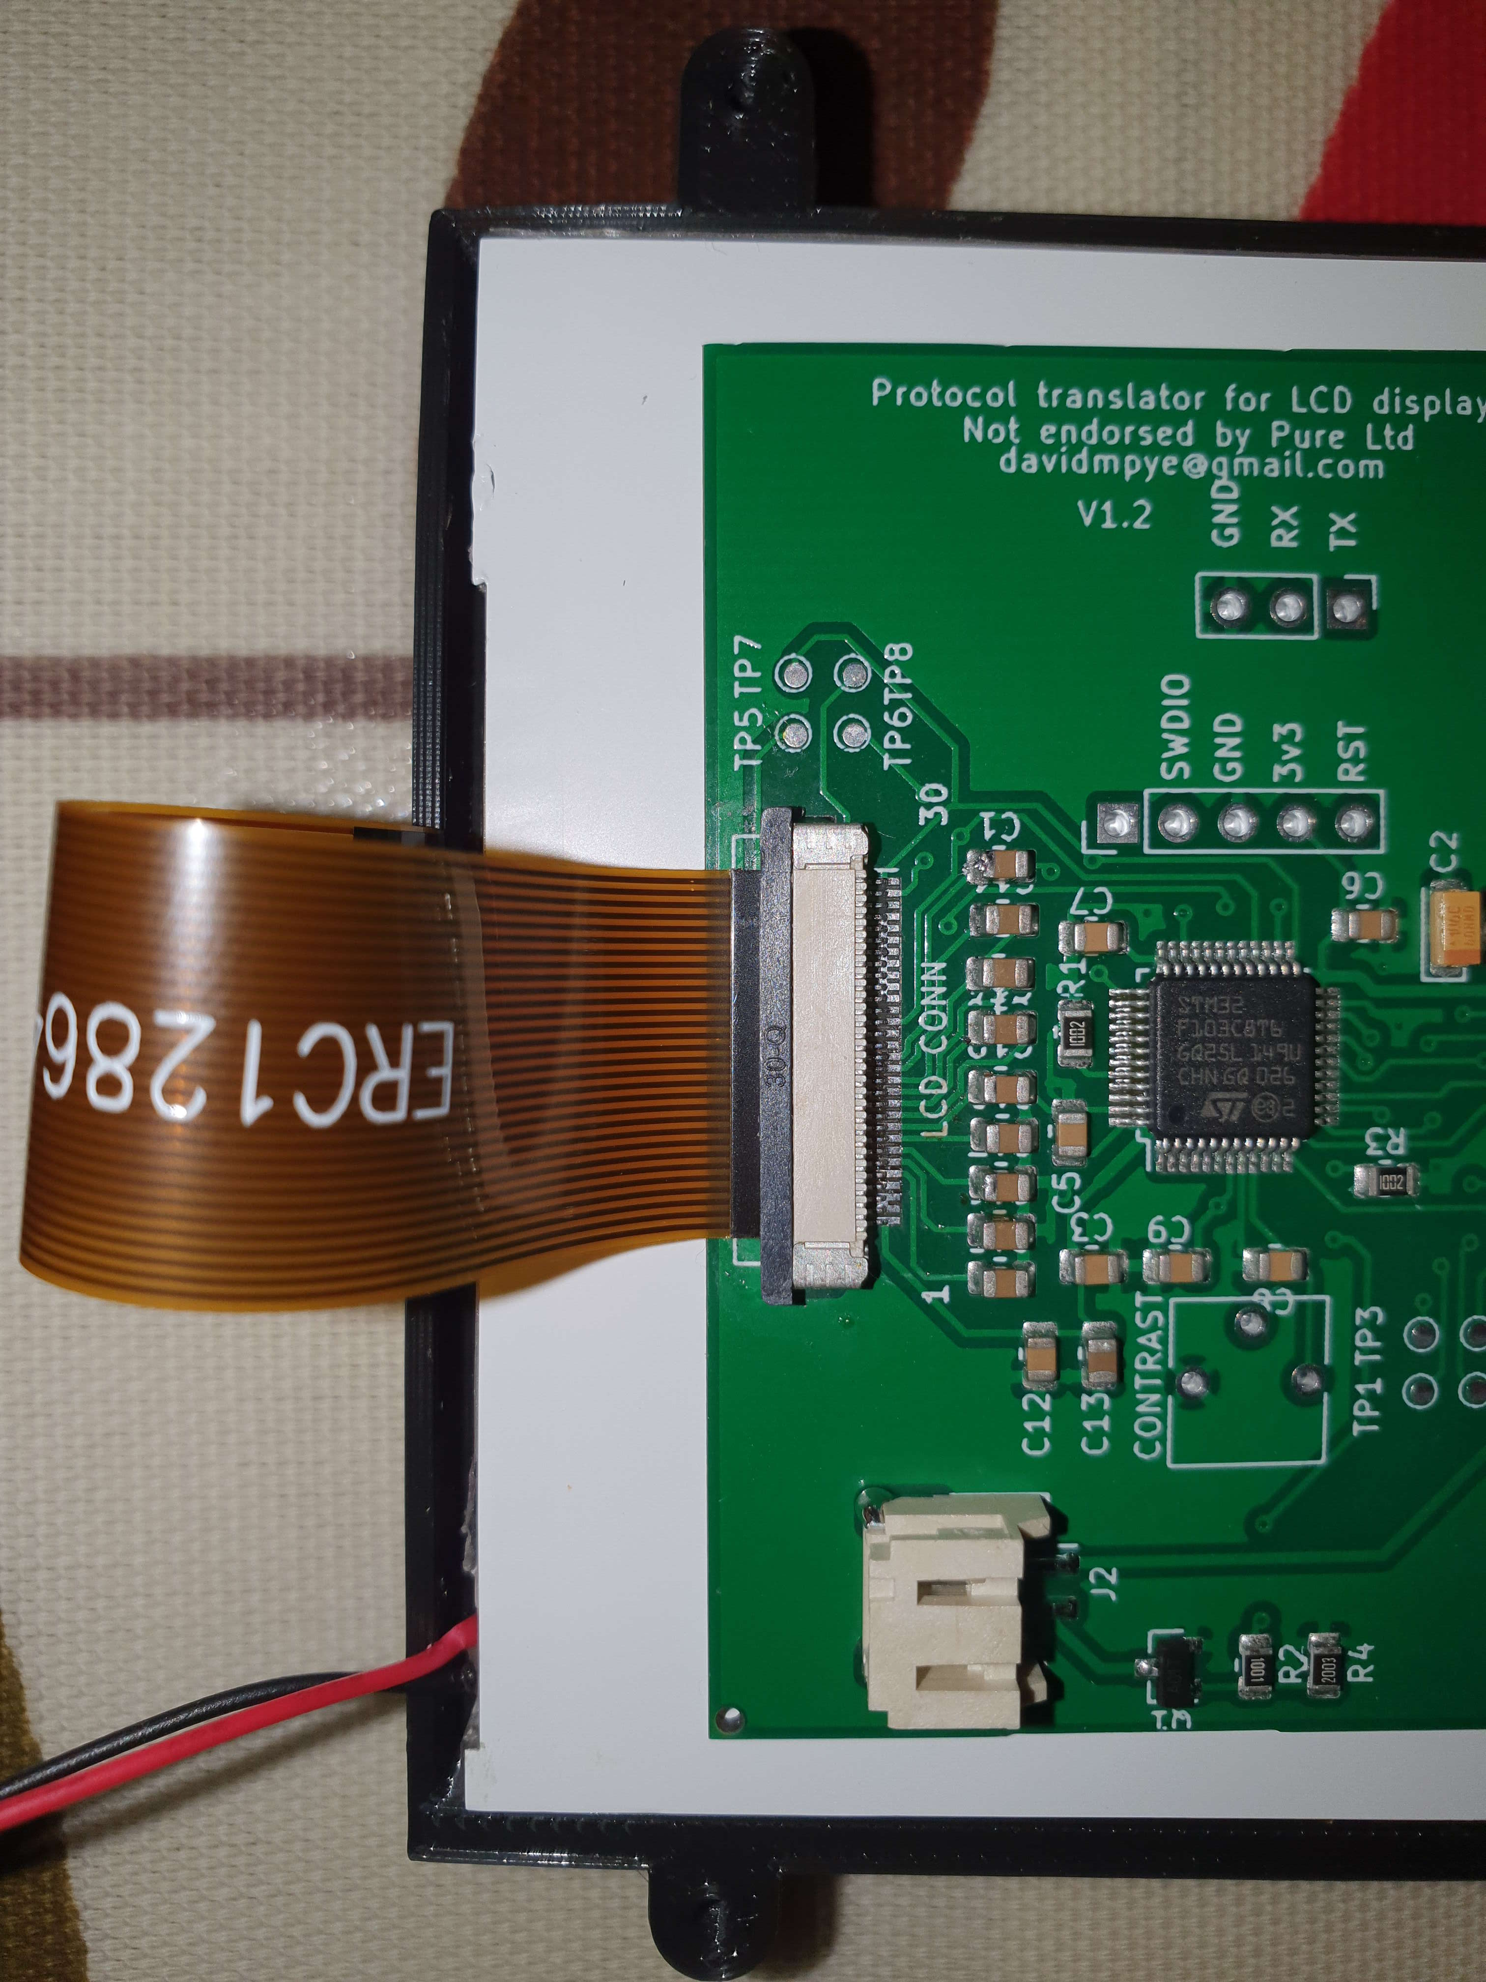
Then, insert the backlight power cable (the red and black wires) into the white socket labelled J2, and push it fully home:
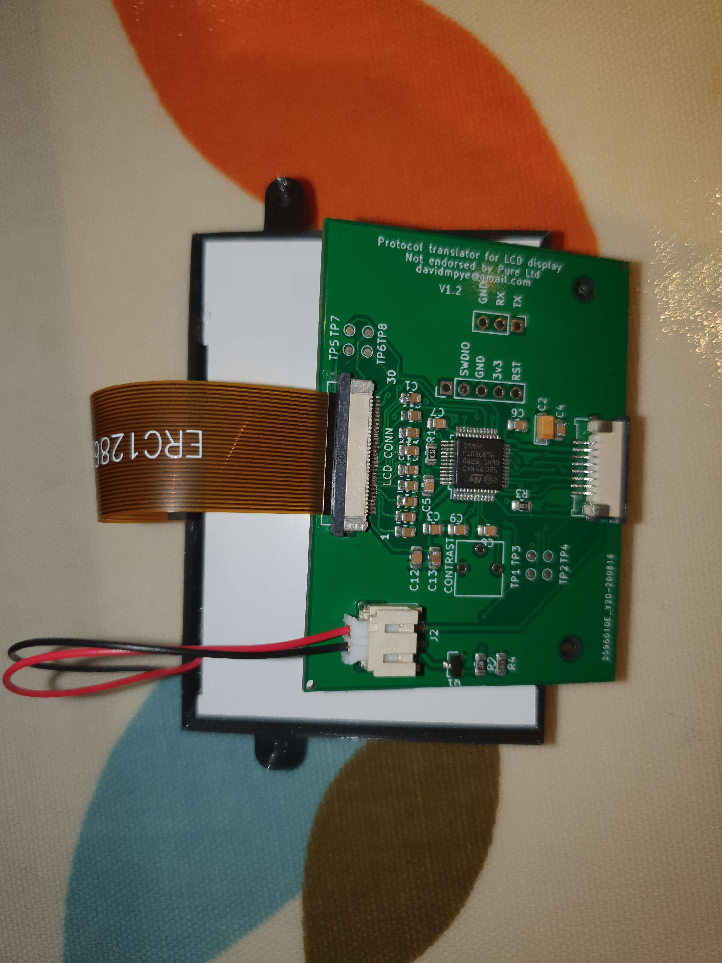
Next, it is time to mount the bracket and display to the radio. Be careful with this step not to stretch or tear the ribbon cable connecting the board and screen – it is fragile.
Gently line up the four lugs on the bracket with the four pegs on the radio casing, and press gently but firmly until it engages into place. It’s sometimes easiest to line the top two up first, then ‘hinge’ the bracket down and engage the other two (firm but gentle pressure may be required to accomplish this.
Secure the display bracket to the radio using the LOWER two screwholes only:
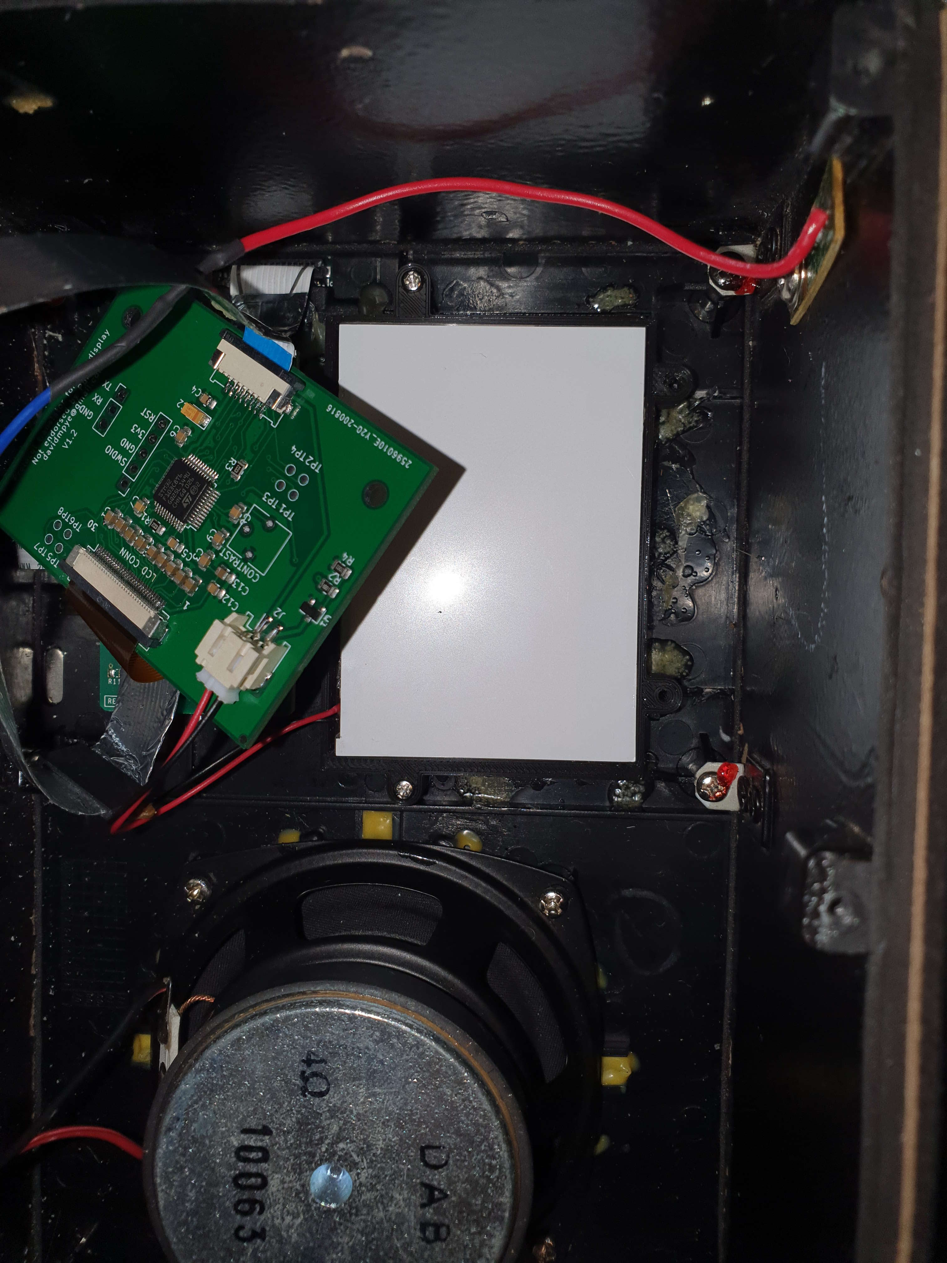
Next, connect the silver cable from the radio to the other connector on the supplied circuit board. This connector has a small retaining clip, with two black lugs at each end. To ‘open’ the connector ready to receive the cable, slide each lug gently with a fingernail horizontally outwards, away from the white part of the connector.

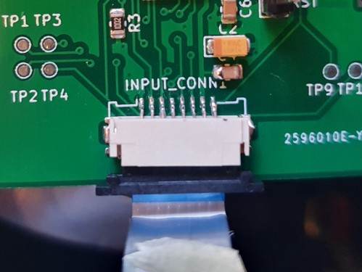
Insert the silver cable with the metal contacts facing down (blue plastic side uppermost as shown in the picture below:

Once the cable is firmly inserted, push the retaining bar back in so it is flush with the connector body, gripping the cable firmly in place.

Now, lower the circuit board into place behind the screen, and secure it into place with two screws through the board, then into the upper screwholes on the bracket. The board will then ensure the screen stays in place in the bracket.

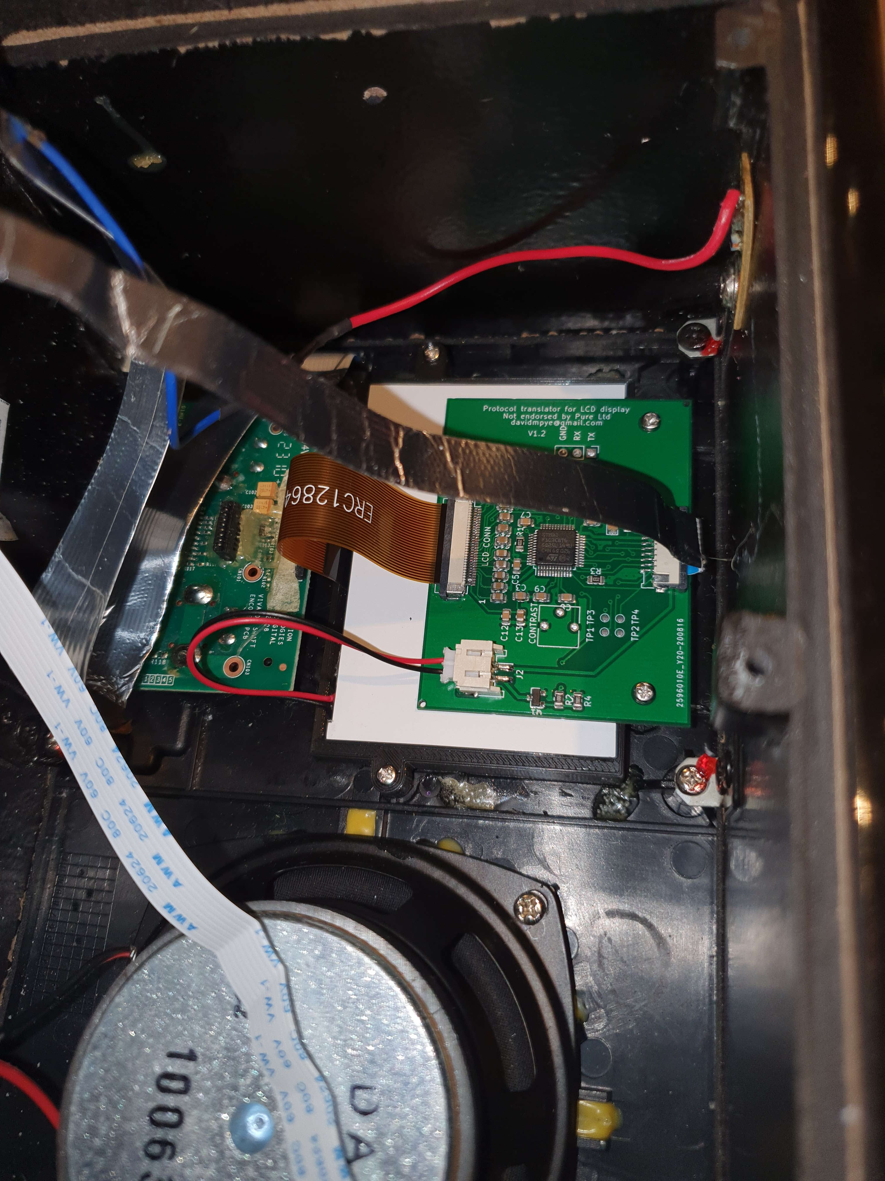
You can now reassemble the two halves of the radio. Check both the ribbon cables between the two halves of the radio are still snuggly inserted.

The left side slides in first to clear the little brackets on the edge of the case, and then it drops in to place. It’s now safe to power on the radio and check that the display works as expected.

Now, install the six retaining screws to hold the back panel on.

Well done – enjoy your newly repaired radio!

Any problems, please get in touch!
David Pye
davidmpye@gmail.com

